Email Templates
Below is customizable text and copy for four donor emails, with banner images sized accordingly. Here is an overview of what is included:
- Welcome
  - 1. Company CEO welcome
- Reminders
  - 3a. Halfway through the campaign
  - 3b. Time is running out!
- Thank You (post- campaign)
  - 4. General thank you to all employees, with campaign stats.

Email 1: Company CEO variation
From: Company CEO, Leader, or Employee Campaign Chair’s first and last name
Audience: All company employees
Call to Action: Give now to join the campaign

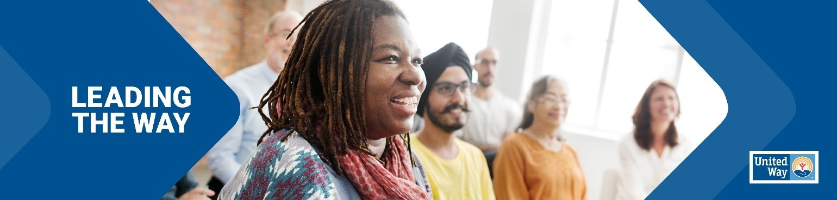
Subject Line: [Company Name] is Leading the Way in Sandusky County
Preheader Text: In our community, everyone deserves the opportunity to thrive.
Email Body:
[Name],
United Way of Sandusky County supports the needs of our community every day to help strengthen our community to ensure everyone will thrive. Join me in leading the way for our community by participating in this year’s campaign. We’ve set an ambitious goal of raising [monetary goal/description] to help do just that.
I believe that when we come together as a team, there’s no challenge that can’t be solved. That’s why I’m inviting you to join me in Leading the Way toward positive change in Sandusky County. This is more than a campaign – it is a call to action for us at [Company Name] to advance solutions to real problems facing people in the communities where we live and work.
Together, we can advance health, youth opportunity, financial security and strengthen overall community resilience to build a future where everyone can reach their full potential. We’re counting on generous people like you and your teammates to help improve the lives of people in our community.
[Insert information about how they can donate]
I want to thank you in advance for your valuable support and for Leading the Way here at [Company Name].
[Closing],
Signature

Email 3a: Reminder #1
From: Company CEO, Leader, or Employee Campaign Chair’s first and last name
Audience: All company employees
Call to Action: Join the campaign by donating

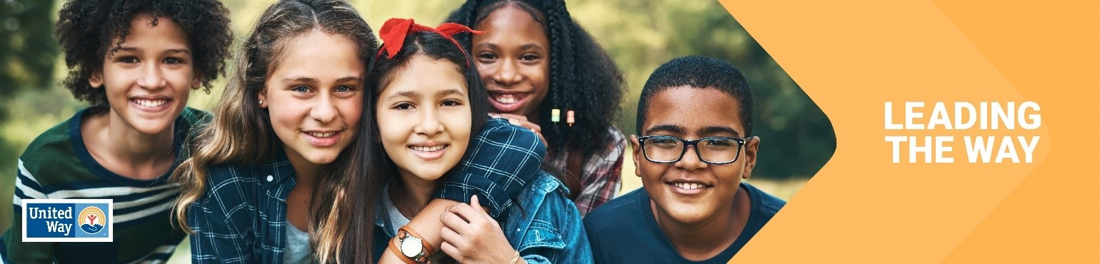
Subject Line: What are we doing together in Sandusky County?
Preheader Text: Mobilizing our community and changing lives.

Email Body:

Hi [Name],
We are already halfway through our United Way Workplace Giving Campaign! Thank you to all of you who have already submitted your pledge form, you understand how important it is to Lead The Way and your investment in our community means you understand United Way’s mission of advancing the common good in our community.
We LEAD THE WAY when we give, advocate and volunteer. United Way helps to create opportunities for a better life by focusing on quality education that leads to a stable job, an income to support a family through retirement, and creating the support seniors need for financial stability. Together, United, we can inspire hope and create opportunities for a better tomorrow.
Our campaign will wrap up on [date]. If you haven’t already, please complete your pledge form and return it by [date]. We hope to announce our total campaign results by [date].
Thank you again for your attention to this important community investment. I am proud to say [company’s name] is LEADING THE WAY!
[Closing],
Signature
Email 3b: Reminder #2 or Final Reminder
From: Company CEO, Leader, or Employee Campaign Chair’s first and last name
Audience: All company employees
Call to Action: Join the campaign by donating

Subject Line: Time is running out to Lead the Way
Preheader Text: Tick, tock…

Email Body:

Have you donated yet to Lead the Way in Sandusky County?

From strengthening local resilience to advancing health, youth opportunity, and financial security, your support is integral to creating impact in our community. Employees at [Company Name] are chipping in and Leading the Way to a better future for everyone in Sandusky County.
Thank you for your continued support!
[Name],
[Closing],
Signature

Email 4: General Thank You #1
From: Company CEO, Leader, or Employee Campaign Chair’s first and last name
Audience: All company employees
Call to Action: See your impact

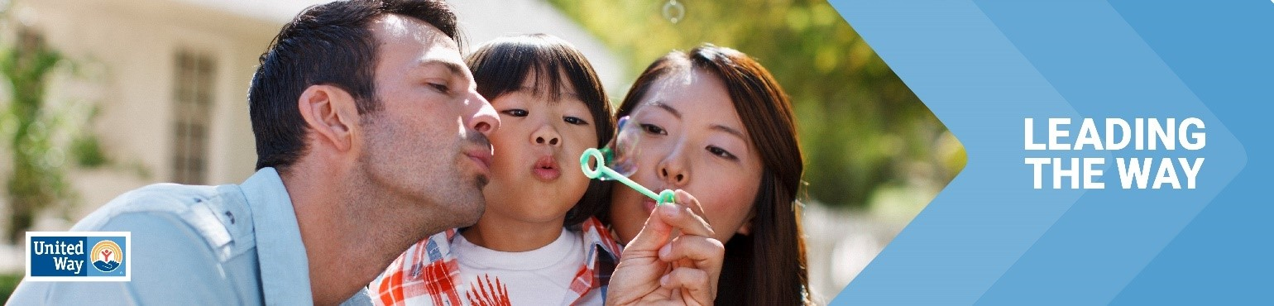

Subject Line: Thank you for Leading the Way in Sandusky County!
Preheader Text: [intentionally left blank]
Email Body:

Dear [Name],

Join me in celebrating the success of [Company Name’s] efforts to Lead the Way by changing lives in Sandusky County.

I’m thrilled to report: [customize]

[Company Name] employees gave $ [dollars pledged] to United Way of Sandusky County
[participation rate%] of [Company Name] Employees gave to United Way of Sandusky County
[number of donors] of [Company Name] employees gave to United Way of Sandusky County
[Company Name] employees contributed more than [number of volunteer hours] volunteer hours during the campaign.

Together, our collective impact is creating a better future for youth, families and communities in Sandusky County. Thank you for Leading the Way!
[Closing],
Signature

